Name: Harsh Ghaoghave PRN : 25070521170
7.1.2 Possible combinations from 3 digits
Algorithm
Step 1: Start the program.
Step 2: Read three space-separated digits as input (a, b, c).
Step 3: Store the three digits in a list or separate variables.
Step 4: Print the first combination by arranging digits as a, b, c.
Step 5: Print the second combination by arranging digits as a, c, b.
Step 6: Print the third combination by arranging digits as b, a, c.
Step 7: Print the fourth combination by arranging digits as b, c, a.
Step 8: Print the fifth combination by arranging digits as c, a, b.
Step 9: Print the sixth combination by arranging digits as c, b, a.
Step 10: Stop the program.
Flowchart
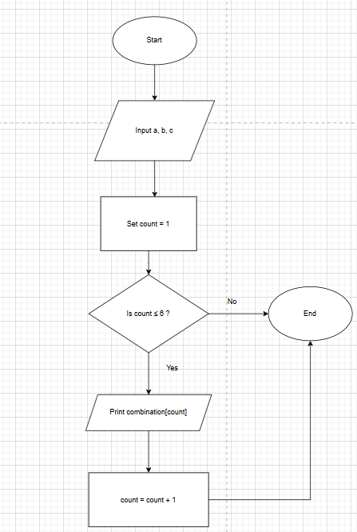

PYTHON CODE
a, b, c = input().split()
digits = [a, b, c]
for i in range(3):
for j in range(3):
for k in range(3):
if i != j and j != k and i != k:
print(digits[i] + digits[j] + digits[k])
Execution
